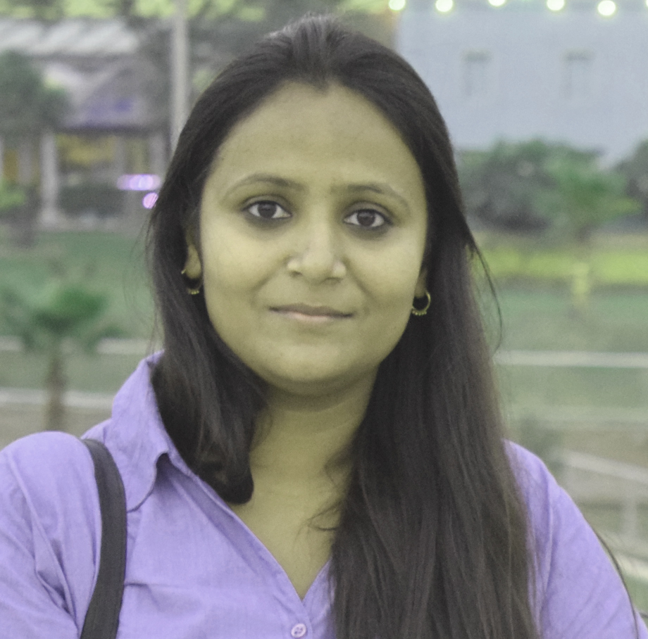
KANCHAN TYAGI
Contact No.: +919999727415(M)
E-Mail: kanchantyagiweb@gmail.com
Website : https://ktbio.xyz

Seeking career enrichment in the domain of Wordpress Web Designing in an organization of high repute

CAREER ABRIDGMENT

- A result oriented professional with six years + of experience in Web Designing.
- Demonstrated excellence in completing web structures for various websites including project assignments.
- Demonstrated abilities in addressing domain/hosting issues, resolving performance bottlenecks and achieving desired objectives.
- Effective communicator with exceptional interpersonal skills.

AREAS OF EXPERTISE

- Designing and implementing new features and functionality
- Establishing and guiding the website’s architecture
- Ensuring high-performance and availability, and managing all technical aspects of the CMS
- Helping formulate an effective, responsive design and turning it into a working theme and plugin.
EXPERIENCE: April 2023 to May ,2024

Worked as a Frontend Developer in My Mudra Fincorp Pvt. Ltd from April 2023 to May,2024.

EXPERIENCE: September, 2019 to June ,2020

Worked as Web designer in Infocom Network ltd. from 11 September,2019 to 08 June,2020. Due to advancement of my pregnancy i left my job since it was not possible to continue in the prevaling pendamic situation (COVID_19).
EXPERIENCE: April, 2019 to August,2019

- April 2019 to August 2019, I am working in Webzesty Pvt Ltd, Moti Nager, New Delhi as a Sr. Web designer. Following are the list of some of my ongoing project which I have made under the WordPress free themes, please go through this link for my portfolio.
- https://www.mymudra.com/
- http://glamcityfashion.com
- http://zestydemo.com/tea
- http://affinityexpresssalon.com/414timber/
- http://zestydemo.com/tray

EXPERIENCE: 2014 to January, 2018

Resigned from Credofy Solutions as a Web Designer

- Job profile is to design individual websites in wordpress including layouts designing using different professional software like Photoshop, Dream weaver etc. and technologies like HTML5, CSS3, Bootstrap, Responsive.
- Good understanding of front-end technologies, including HTML5, CSS3.
- Experience designing and developing responsive design websites
- Comfortable working with debugging tools like Firebug, Chrome inspector, etc.
- Ability to understand CSS changes and their ramifications to ensure consistent style across platforms and browsers
- Ability to convert comprehensive layout and wireframes into working HTML pages
- Understanding of PHP back-end development
EXPERIENCE : 2008 to 2010
- Working in Vigyan Vijay Foundation (VVF) as a Faculty of Web Designing, DTP, DBCL with the following responsibilities.
- Assisting juniors in the various training Programme of Computer Applications.
- Reporting, Documentation and Monitoring
- Course Designed
- Implemented suitable method for reducing the time duration of working of computer within the time schedule.
Latest Projects

- http://www.lintgroup.com
- https://www.inshutters.co.uk/
- https://www.cheadleglass.com
- https://www.bv-ag.ch/fr/
- http://www.bocamusicgroup.com/
- http://sharkcontent.com/
- http://www.tailormade360.co.uk/
- http://arcticrallyexperience.co.uk/
- http://www.nextproperty.co.uk/home-new/
- https://www.twinemanagement.co.uk
- http://optimise5.com/
- http://www.adeocreative.com/procaddie
- http://www.responsivewebsitesdesign.com/client/nkplanning/
- http://www.bestsurpriseeggvideos.com
- http://www.churchdesign.guru/
- http://embracebeautyacademy.co.uk/
- http://clanmacmedia.com/
- http://dwasurveyors.co.uk/
- http://astrolondon.co.uk/
- lots of more....

ACADEMIC CREDENTIALS

- Pursuing php, bootstrap, Wireframe, Covert PSD to Wordpress/ bootstrap from Animation Boom Institute, Dwarka, New Delhi.
- Successfully completed 6 month web designing course from NIIT in 2009.
- One year diploma in Software application from MEGA TECH, Dwarka, New Delhi in 2008.
- Graduation from Delhi University in 2007.

IT FORTE

Operating Systems : Windows 2007. XP Windows 10.
Other Packages : HTML, CSS, Dreamweaver, Illustrator, Photoshop, Bootstrap,
Responsive Web Design, Html5,Wordpress.

PERSONAL DETAILS

Nationality Indian
Marital Status Married
Languages Known: English and Hindi
Permanent Address: D2/22, Vijay Enclave, Vinodpuri, Palam Dabari Road, New Delhi-
110045

